Capstone Project on Movie Rental Analysis:

SHRIRAJ RAKTATE

**Project Overview:**

The aim of this project is to create a comprehensive Power BI dashboard using the Sakila DVD Rental Store Database, supplying valuable insights into the rental store business. The analysis will focus on customer behaviour, film inventory management, staff performance, and store operations. The goal is to enable data-driven decision-making and improve overall business performance. The Power BI dashboard will offer insights into customer segmentation, sales trends, film performance, staff productivity, and store revenue.

The primary aim is to perfect film inventory, enhance customer satisfaction, improve staff performance, and streamline store operations. The dashboard will give actionable recommendations for targeted marketing campaigns, film collection enhancements, and staff training initiatives to improve business performance. The final deliverables will include a report and presentation highlighting the dashboard's findings and recommendations. The Power BI dashboard will serve as a valuable tool for rental store owners to make informed decisions and achieve success in the competitive DVD rental market.

In addition to creating a Power BI dashboard, this project also includes a vital phase of Exploratory Data Analysis (EDA). EDA involves the use of SQL queries to extract and examine the dataset for critical insights. SQL queries were employed to address specific problem statements related to customer behaviour, film inventory, staff performance, and store operations. These queries helped uncover patterns, trends, and anomalies in the data.

For Presenting the results of the EDA effectively, visualizations were prepared and organized in an Excel file. These visualizations include charts, graphs, and tables that highlight key findings and patterns. The Excel file serves as a complementary resource to the Power BI dashboard, providing stakeholders with a comprehensive view of the project's insights.

**The Processes:**

**1) Data Acquisition from GitHub:**

It includes collection of data of movie rental analysis from specific github repository, which include data and resources pertinent to rented films of different category along with customer details. After checking data ensured and checking the data is publicly accessible. And downloading the data ensured that the data obtained in formats compatible with chosen analysis tools, such as SQL-Script for database queries and Power BI for visualizations.

**2) Data Transformation:**

Data transformation is a critical step in project that involves shaping and preparing the bought datasets for meaningful analysis. The techniques include data filtering, where I select relevant rows and columns, and data aggregation, which allows us to group and summarize information. I also perform data joining to combine multiple datasets using common keys, and data splitting to divide data into subsets based on specific criteria. Reshaping the data through pivoting or melting helps us change its structure to align with analysis goals. Encoding categorical data into numerical format, scaling numerical values for consistency, and imputing missing data are essential steps to ensure data integrity and relevance. Feature engineering enables us to create new variables that capture meaningful patterns, while parsing dates helps us extract relevant time-based information. These transformations are pivotal in preparing data for the later analysis.

**3) Data Cleaning:**

Data cleaning is an indispensable aspect of data preparation process, aimed at improving data quality and accuracy. In this phase, I address various data anomalies and inconsistencies to ensure the reliability of analysis. Data deduplication removed the data, which helps cut duplicate records that might skew results, while outlier handling names and mitigates outliers that could distort findings. Noise reduction techniques applied to smooth or filter noisy data points that may introduce errors. Data type conversion ensures data types are consistent and suitable for the intended analysis. I also stan whitespace and admit correct case sensitivity issues, trim extraneous whitespace, and perform spell checking to rectify typographical errors. Managing null and zero values, resolving inconsistent data, and rounding numerical data are vital tasks in data cleaning. Redundant or removed irrelevant data, and code mapping assigns meaningful labels to codes. Statistical analysis and linearity assessment help in finding anomalies and patterns.

**4)MECE Breakdown:**

In This project, I adopt a MECE (Mutually Exclusive, Collectively Exhaustive) strategy to ensure a logical and structured progression of data from one phase to the next. This approach serves to organize project components and the seamless dividend of data into next analyses. The project divided into distinct and mutually exclusive phases that focus on specific aspects of the movie rental business. These phases encompass data acquisition, exploratory data analysis (EDA), problem statement resolution through SQL, visualization with Power BI, and next analyses. Each phase has its unique purpose and contributes to the overall project goals without overlapping or duplicating efforts.

**5)Connecting with Tools:**

SQL scripts play a crucial role in project, enabling us to extract and manipulate data directly from a relational database. It supplies seamless connectivity to SQL databases, allowing us to input SQL scripts and query data.

For incorporating CSV data into analysis, I use Power BI's robust data import capabilities. Power BI offers a straightforward and intuitive approach for connecting to CSV files. I access and import CSV data by specifying the file location, ensuring compatibility and consistency with analysis aims. Through this connection, I can easily manipulate, transform, and visualize data directly within Power BI, thus simplifying the data preparation phase.

**6)Exploratory Data Analysis:**

Exploratory Data Analysis (EDA) is an indispensable phase in project. For Begin with the EDA process, I employ SQL queries to tackle specific problem statements. SQL queries offer powerful capabilities for data extraction, transformation, and aggregation, making it a versatile tool for preliminary data analysis. I use SQL to address questions related to customer behaviour, film inventory, staff performance, and store operations. SQL helps us filter, group, and aggregate data to extract relevant information with capability of handling enormous amounts of data. It involves a comprehensive examination of the bought datasets to gain a deeper understanding of the data, find patterns, and extract valuable insights. I use Excel's extensive charting and graphing capabilities to generate informative visualizations, such as bar charts, line graphs, pie charts, and scatter plots. These visualizations supply a clear and concise way to present the outcomes of SQL queries, enabling stakeholders to grasp the insights easily. The combination of SQL for data analysis and Excel for visualization results in a dynamic and interactive approach to EDA.

**6)Power-Bi Analysis:**

Power BI gives a powerful platform for creating interactive and insightful visualizations that transform raw data into meaningful representations. This phase allows us to translate the insights into visually engaging dashboards that address the challenges found during EDA. It involves use of Bar/Columns charts, Pie-charts, Area-charts, Line-charts & matrix-chart for making visualizations along with the insights which are getting by analysing charts. The integration of Power BI visualizations adds a dynamic and interactive dimension to the project. It transforms data give insights & dashboard into actionable recommendations that are readily accessible to stakeholders, store owners, and decision-makers, needed for success.

**7) Documentation:**

Documentation is a cornerstone of project, ensuring that organized work, accessible, and comprehensible to all stakeholders. I have created a comprehensive documentation strategy that includes diverse types of files to capture the various aspects of the project. I have done all documentation of project in a Microsoft Word file which have all information of project.

**Objectives:**

1. **Data Exploration and Understanding:** Projects primary aim is to thoroughly explore and understand the dataset derived from the movie rental industry. I aim to gain insights into the data's structure, relationships, and potential areas for analysis.
2. **Customer Segmentation and Profiling:** I intend to segment customers based on their rental behaviours, preferences, and demographics. By creating customer profiles, I offer targeted marketing strategies and personalized recommendations.
3. **Film Performance Analysis:** This project looks to analyse the performance of films within the rental store. This includes finding top-performing films, assessing their popularity, and recommending strategies for buying or promoting films to perfect revenue.
4. **Staff Productivity Assessment:** An important aim is to assess the productivity and performance of staff members. I aim to find high-performing employees, pinpoint areas for improvement, and recommend staff training or incentive programs.
5. **Store Operations Efficiency:** The project strives to enhance the overall efficiency of store operations. By analysing operational data, I find bottlenecks, streamline processes, and improve store revenue while keeping or reducing costs.
6. **Data Visualization and Storytelling:** I aim to create informative and engaging data visualizations using Power BI to effectively communicate my findings. These visualizations should tell a compelling data-driven story that is easy for stakeholders to understand.
7. **Informed Decision-Making**: My overarching aim is to provide rental store owners and decision-makers with the insights and recommendations needed to make informed decisions. I want to empower them with the tools to drive success in the competitive movie rental market.

These revised aims should supply a clearer focus on data exploration, customer segmentation, film performance analysis, staff productivity, store operations, and effective communication of findings. They are well-aligned with the dataset and the goals of movie rental analysis project.

**Significance:**

1. **Data-Driven Decision-Making:** In an era where data plays a vital role in shaping business strategies, this project empowers rental store owners and stakeholders with the tools and insights needed for data-driven decision-making. By analysing customer behaviour, perfecting film inventory, enhancing staff performance, and streamlining store operations, this project enables informed choices that have a direct impact on business success.
2. **Customer-Centric Approach:** Understanding customer behaviour is at the heart of the project's significance. By segmenting customers, personalizing marketing strategies, and improving customer satisfaction, contribute to a customer-centric approach that can enhance loyalty and drive revenue growth.
3. **Efficiency and Cost Reduction:** This project addresses the need for efficiency and cost reduction by perfecting film inventory and store operations. By finding top-performing films, streamlining operational processes, and reducing unnecessary costs, contribute to improved profitability and sustainability for rental stores.
4. **Competitive Advantage:** In a highly competitive market, the project provides rental store owners with a competitive advantage. Through data insights, recommended marketing strategies, and staff performance enhancements, project equips businesses with the means to outperform competitors and excel in the industry.
5. **Data Quality and Reliability:** Ensuring data quality and reliability is paramount in project. By performing data cleaning and validation, I not only improve the quality of the analysis but also set a standard for the integrity of data in the industry. This has far-reaching implications for other businesses and data-driven ventures.
6. **Transparency and Reproducibility:** This project embraces transparency and reproducibility by documenting the entire process and methods. This approach sets a precedent for projects in various domains, emphasizing the importance of open and transparent data analysis practices.
7. **Knowledge Transfer and Education:** The insights and recommendations generated by project serve as valuable educational resources. They can use to educate stakeholders, staff, and the wider industry on the benefits of data analysis and data-driven decision-making.
8. **Stakeholder Empowerment:** This project aims to empower stakeholders, rental store owners, and decision-makers with the knowledge and tools needed to succeed in the movie rental market. It serves as a catalyst for positive change and business growth. The significance of this project extends beyond the movie rental industry, highlighting the transformative power of data analysis, customer-centric strategies, and operational efficiency in any business context.

**Data Dictionary:**

Dataset is a comprehensive collection of information from a movie rental service, encompassing a wide array of tables with details on actors, films, customers, rental transactions, & more. This rich dataset forms the foundation of my analysis, supplying insights into customer behaviour, film inventory management, & operations.

**Table Explanations:**

**Actor Table:** The actor table lists information for all the actors.

* Actor id (Primary Key): A unique identifier for each actor.
* first name: The first name of the actor.
* last name: The last name of the actor.

**Address Table:** The address table has address information for customers, staff.

* Address id (Primary Key): A unique identifier for each address.
* address: The street address.
* address2: Additional address information, if available.
* district: The district or area.
* City id (Foreign Key): A reference to the city table, standing for the city where the address is present.
* Postal code: The postal code.
* phone: The phone number associated with the address.

**Category Table:** The category table lists the categories that can assigned to films.

* Category id (Primary Key): A unique identifier for each category.
* name: The name of the category.

**City Table:** The city table holds a list of cities.

* City id (Primary Key): A unique identifier for each city.
* city: The name of the city.
* Country id (Foreign Key): A reference to the Country table, standing for the country or region where the city is present.

**Country Table:** The country table holds a list of countries or regions.

* Country id (Primary Key): A unique identifier for each country.
* country: The name of the country or region.

**Customer Table**: The customer table holds a list of all customers.

* Customer id (Primary Key): A unique identifier for each customer.
* Store id (Foreign Key): A reference to the Store table, showing the store where the customer registered.
* First name: The first name of the customer.
* last name: The last name of the customer.
* email: The customer's email address.
* Address id (Foreign Key): A reference to the Address table, specifying the customer's address.
* active: A flag showing whether the customer's account is active.
* Create date: The date when the customers created account.

**Film Table:** The film table lists all the films that may be in stock in the store.

* Film id (Primary Key): A unique identifier for each film.
* title: The title of the film.
* description: A brief description of the film.
* Release year: The year when the film released.
* Language id (Foreign Key): A reference to the Language table, specifying the film's language.
* Original language id (Foreign Key): A reference to the Language table, standing for the original language of the film.
* Rental duration: The rental duration of the film.
* Rental rate: The rental rate for the film.
* Replacement cost: The cost to replace the film.
* rating: The film's content rating.

**Film text Table:** The content of the film text table kept in synchrony with the film table by triggers on the film table INSERT, UPDATE, and DELETE operations.

* Film id (Foreign Key): A reference to the Film table, with film title.
* film title: The title of the film.
* description: A brief description of the film.

**Film actor Table:** The film actor table support many to many relationships’ films and actors.

* Actor id (Foreign Key): A reference to the Actor table, stands for the actor associated with the film.
* Film id (Foreign Key): A reference to the Film table, showing the film in which, the actor appeared.

**Film category Table:** The film category table support many to many relationships between films and categories.

* Film id (Foreign Key): A reference to the Film table, specifying the film associated with a category.
* Category id (Foreign Key): A reference to the Category table, showing the category assigned to the film.

**Inventory Table:** The inventory table is a copy of a given film in each store.

* Inventory id (Primary Key): A unique identifier for each inventory item.
* Film id (Foreign Key): A reference to the Film table, stands for the film in the inventory.
* Store id (Foreign Key): A reference to the Store table, showing the store where the inventory item is.
* last update: The date and time when the inventory item updated.

**Language Table:** The table lists all values for the film & original language.

* Language id (Primary Key): A unique identifier for each language.
* name: The name of the language.

**Payment Table**: The payment table records every payment made by the customer, including information such as the amount and rent paid.

* Payment id (Primary Key): A unique identifier for each payment transaction.
* Customer id (Foreign Key): A reference to the Customer table, specifying the customer who made the payment.
* Staff id (Foreign Key): A reference to the Staff table, showing the staff member who processed the payment.
* Rental id (Foreign Key): A reference to the Rental table, standing for the rental associated with the payment.
* amount: The payment amount.
* Payment date: The date and time when of the payment.

**Rental Table:** The rental table holds a row for each rental of each inventory item, which holds information about who rented what, when it rented it, and when it returned.

* Rental id (Primary Key): A unique identifier for each rental transaction.
* Rental date: The date and time when the movie rented.
* Inventory id (Foreign Key): A reference to the Inventory table, showing the inventory item rented.
* Customer id (Foreign Key): A reference to the Customer table, specifying the customer who rented the film.
* Return date: The date and time when the rental returned.
* Staff id (Foreign Key): A reference to the Staff table, standing for the staff member who processed the rental.

**Staff Table:** The staff table lists all staff information, including email addresses, login information, and pictures.

* Staff id (Primary Key): A unique identifier for each staff member.
* first name: The first name of the staff member.
* last name: The last name of the staff member.
* Address id (Foreign Key): A reference to the Address table, specifying the staff member's address.
* email: The email address of the staff member.
* Store id (Foreign Key): A reference to the Store table, showing the store where the staff member works.
* active: A flag showing whether the staff member is currently active.
* username: The staff member's username for system login.
* password: The staff member's password for system login.
* last update: The date and time of the staff member's last update.

**Store Table:** The store table lists all stores in the system.

* Store id (Primary Key): A unique identifier for each store.
* Manager staff id (Foreign Key): A reference to the Staff table, standing for the staff member who manages the store.
* Address id (Foreign Key): A reference to the Address table, specifying the store's address.

**Entity Relationship (ER) Diagram:**

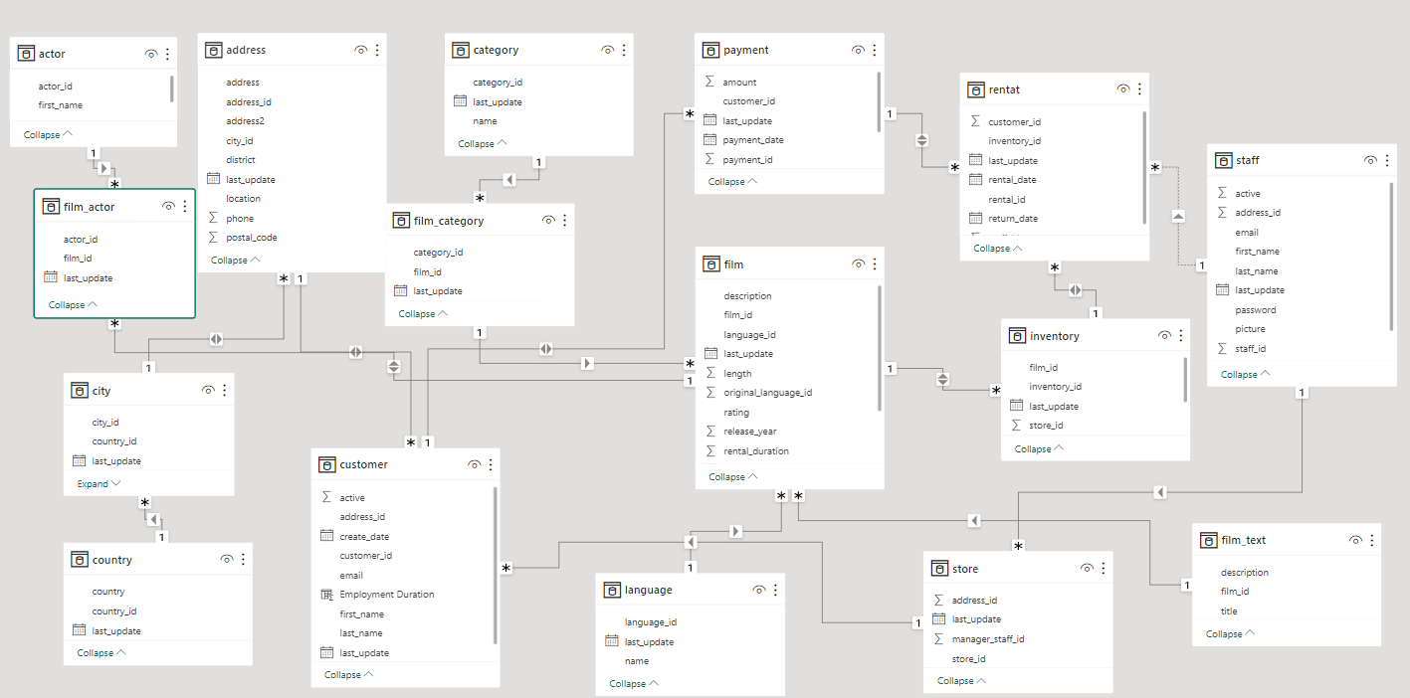

**MECE Breakdown**

**Customer Analysis:**

* Demographics: Categorize customers by gender, location(city/country).
* Language: Customers mostly prefer which language movies.
* Status: Identify number of Active or Inactive customer.

**Rental Analysis:**

* Rental Trends: Examine Rental duration & returning times of customers.
* How often film rented: Examine how often individual customers rent films.
* Rental Returned: Track the return dates of rentals, to check if they are late.

**Revenue Analysis:**

* Revenue Trends: Examine Revenue variation by countries & by Film Categories.
* Revenue: Examine Revenue by Rental Duration.
* Distribution: Inventory wise Revenue Distribution.

**Film Analysis:**

* Film Popularity: Find most & least rented films.
* Rating Analysis: Find how film ratings relate to rentals.
* Special Feature: Find which specific features mostly use in films.
* Film Length: Study customer viewing habits and rental choices related to film length.

**Location Analysis:**

* Revenue: Analyse Country wise Revenue.
* Rating: Country wise Rental Rate & Rental Duration.
* Distribution: Customer Distribution by Country.

**Actor Analysis:**

* Appearance: Identify actors who appear in the most-rented films.
* Performance: Which actor has a greater number of popular films & contributing more Revenue.
* Variation: Actor wise Rental Rate Variation.

**Exploratory Data Analysis:**

**Problem Statement:**

1) What are the purchasing patterns of new customers versus repeat customers?

**SQL-Query:**

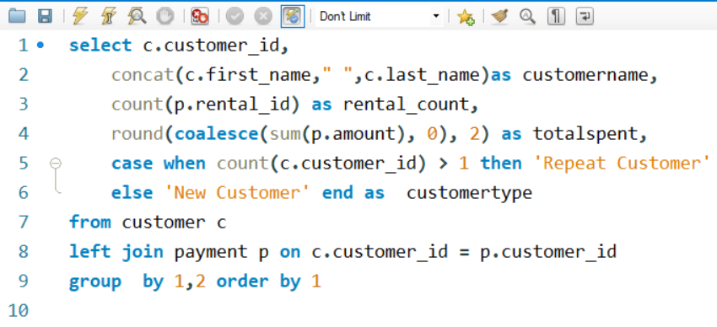

**Insights:**

The line chart depicting the purchasing patterns of new customers versus repeat customers provides essential insights into customer behavior and highlights significant opportunities for the rental store's marketing and engagement strategies. The chart clearly illustrates that a portion of new customers has not yet made any purchases. This finding is crucial as it indicates a potential gap in the onboarding process or customer engagement.

It's essential to recognize that the portion of new customers not making purchases represents untapped potential. This untapped customer segment can be a goldmine if approached strategically. Targeted marketing efforts, such as welcome discounts or personalized recommendations, can be devised to convert these prospects into paying customers, thereby increasing revenue.

Moreover, tracking the progression of customers with no purchases is vital for measuring the effectiveness of onboarding and engagement strategies. It allows the rental store to identify where in the customer journey these individuals drop off or disengage, facilitating a more informed and data-driven approach to improve customer retention and satisfaction.

By understanding these patterns and taking corrective actions, the rental store can enhance the overall customer experience and potentially increase customer lifetime value, ultimately contributing to its success in the competitive movie rental market.

**Problem Statement**:

2) Which films have the highest rental-rates and are most in demand?

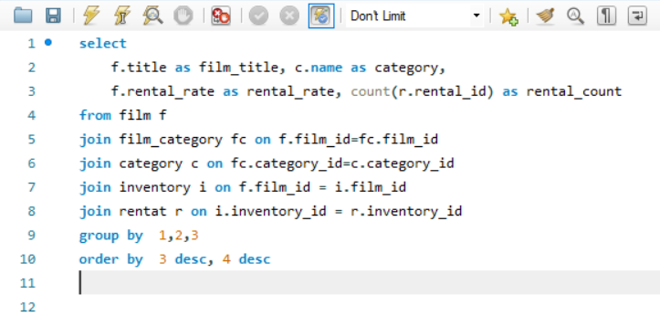**SQL-Query:**

**Visualization:**

**Insights:**

The chart vividly illustrates a compelling trend – films with higher rental rates tend to be in high demand. This correlation signifies that customers are not only willing to pay more for films but are also actively seeking out movies that they find highly appealing and entertaining. As a prime example, the movie "BUCKET BROTHERHOOD" exhibits both higher rental rates and remarkable demand, highlighting its strong desirability among viewers.

This observation is of paramount significance for rental stores. By analysing films with the highest rental rates and demand, rental businesses can strategically prioritize their inventory and marketing endeavours. This entails ensuring that popular titles, particularly those that combine affordability with high demand, are readily available to cater to customer preferences.

Maximize revenue, rental stores can consider promoting films that strike this balance between high rental rates and high demand. Such films are not only likely to generate substantial income but also reflect customer preferences. Implementing this strategy can prove to be a revenue booster, aligning inventory with customer expectations and driving profitability.

The chart underscores the powerful interplay between rental rates, customer demand, and film popularity. It emphasizes the importance of data-informed inventory management and marketing strategies for rental stores. By aligning their offerings with customer preferences, rental stores can enhance customer satisfaction and revenue, thriving in the competitive movie rental market.

**Problem Statement:**

1. 3)Are there correlations between staff performance and customer satisfaction?

.

**SQL-Query:**

**Insights:**

The area chart gives a nuanced view of the rental duration distribution, notably featuring early returns, and late returns. A generous part of customers returns films within the expected 3 to 7-day duration, adhering to the store's guidelines.

However, the chart also highlights that a considerable number of customers show early return behaviour, showing a preference for prompt film returns. Simultaneously, there are instances of late returns, suggesting customers might receive help from late return policies or incentives for early returns to streamline their movie rental experience.

Analysing this customer rental behaviour is not only useful for managing inventory more effectively but also for making data-driven decisions. The rental store can use this data to strike a balance between customer convenience and operational efficiency, enhancing customer satisfaction and store performance.

This insight-driven approach empowers the rental store to refine its rental policies and customer engagement strategies, aiming for a best and harmonious movie rental experience.

**Problem Statement:**

4)Are there seasonal trends in customer behaviour across distinct locations?

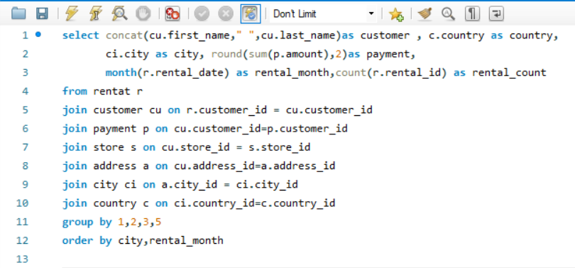**SQL-Query:**

**Visualization:**

**Insights:**

The analysis of seasonal trends in customer behavior across diverse locations unveils a captivating narrative - specific film categories witness a surge in demand during distinct seasons. This chart elegantly illustrates these fluctuations, with an unmistakable pattern emerging. Notably, more customers engage in film-watching activities during the sixth month (July) and the eighth month (October), marking these periods as peak seasons for movie rentals. Conversely, customer engagement tends to wane during the second month (February), signaling lower viewership.

These seasonal variations present a significant opportunity for rental stores to fine-tune their inventory management strategies. By aligning their film offerings with the ebb and flow of customer preferences, rental businesses can ensure they stock the right films to cater to the heightened demand during peak seasons. This strategic approach isn't just about increasing customer satisfaction; it's also a revenue optimization tactic that can significantly impact the bottom line.

Furthermore, by tracking customer preferences over the seasons, rental stores can craft targeted marketing campaigns and promotions that capitalize on these well-defined trends. This proactive approach can attract more customers during peak seasons, offering tailored experiences and incentives that further elevate customer engagement and drive rental revenue to new heights.

In essence, this chart showcasing seasonal trends in customer behavior represents an invaluable tool for rental stores seeking to enhance their operations. It highlights the potential for strategic inventory management and targeted marketing efforts that cater to customer desires throughout the year, ultimately positioning rental businesses for success in a dynamic and competitive movie rental market.

**Problem Statement:**

5) **Are certain language films more popular among specific customer segments?**

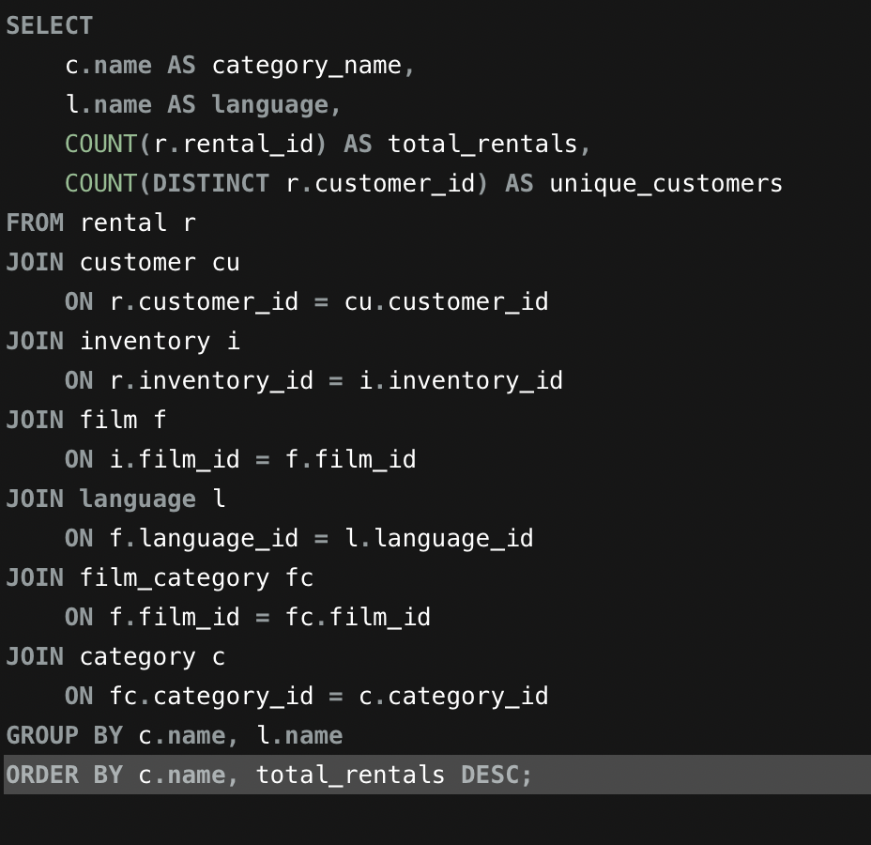**SQL-Query:**

**Visualization:**

**Problem Statement:**

6)How customer loyalty impact sales revenue over time?

**SQL-Query:**

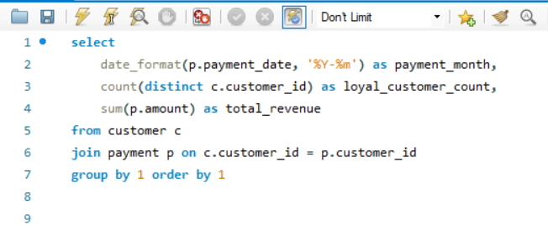

**Visualization:**

|  |  |  |
| --- | --- | --- |
| **payment month** | **Loyal customer count** | **total revenue** |
| 2005-05 | 455 | 4239.83 |
| 2005-06 | 512 | 8438.63 |
| 2005-07 | 521 | 24618.63 |
| 2005-08 | 520 | 21092.2 |
| 2006-02 | 134 | 442.44 |

**Insights:**

The provided output paints a vivid picture of the correlation between customer loyalty and revenue growth over time. Notably, the seventh (2005-07) and eighth (2005-08) months appear as peak periods, boasting the highest count of loyal customers and generating substantial revenue. This observation underscores the pivotal role that customer loyalty plays in the financial trajectory of the rental store.

Customer loyalty is not merely a fleeting attribute but a significant driver of long-term revenue generation. Loyal customers form the backbone of a successful rental business, consistently making more frequent and higher-value transactions over time. Their sustained engagement and repeated patronage contribute significantly to the store's sustainable financial success.

The data underscores the importance of nurturing and keeping loyal customers as a strategic imperative for rental stores. By offering exceptional customer experiences, personalized recommendations, and rewards for loyalty, rental businesses can further solidify their customer base and keep a steady revenue stream. Furthermore, the identification of peak months in terms of loyal customer count and revenue generation supplies valuable insights into when to focus marketing efforts and loyalty initiatives for best impact.

In summary, this data illuminates the symbiotic relationship between customer loyalty and revenue growth. It highlights the pivotal role of loyal customers in ensuring the long-term financial health and success of the rental store. By fostering and capitalizing on customer loyalty, rental businesses can secure their competitive edge in the movie rental industry and continue to thrive in an ever-evolving market.

**Problem Statement:**

7) Are certain film categories more popular in specific locations?

**SQL-Query:**

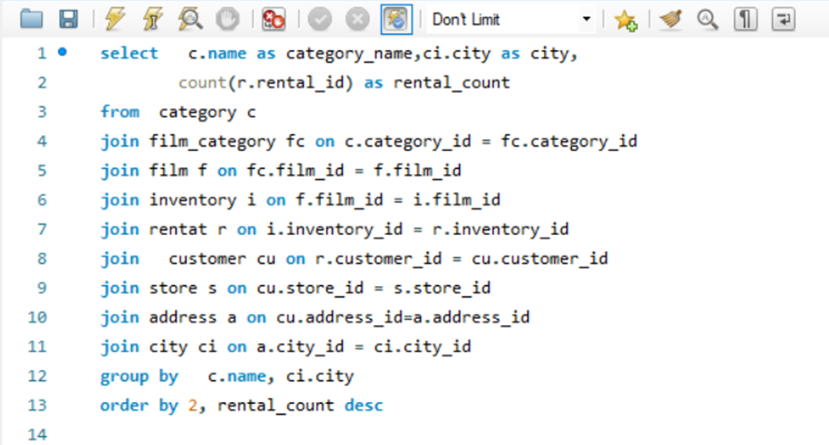

**Visualization:** 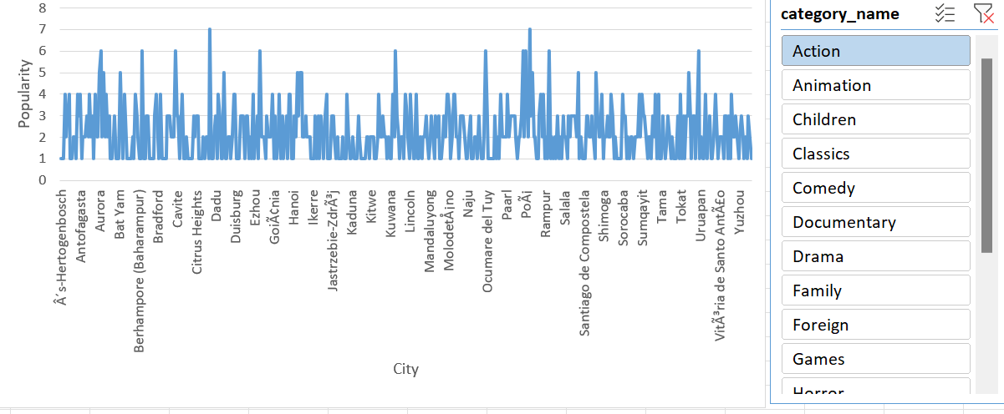

**Insights:**

The chart effectively illustrates the fascinating phenomenon of varying film category preferences across distinct locations. Notably, that “Action” and “Sport” categories stand out as the most popular film categories in the depicted locations. This observation underlines the significance of understanding the nuanced film tastes of diverse customer bases.

The data chart contributes to a deeper comprehension of the intricacies of film category popularity within distinct regions. This insight, in turn, opens avenues for rental stores to adopt more targeted marketing and inventory management strategies. By acknowledging the preferences of specific locations, rental businesses can curate their offerings to align with local tastes. This strategic approach has the potential to elevate customer satisfaction and, after, enhance overall rental revenue.

The chart is a valuable tool for rental stores looking to tailor their services to the diverse demands of their customer base. Recognizing the unique popularity of film categories in various locations empowers rental businesses to craft a more personalized and customer-centric approach, solidifying their position in the competitive movie rental market.

**Problem Statement:**

8) How does the availability and knowledge of staff affect customer ratings?

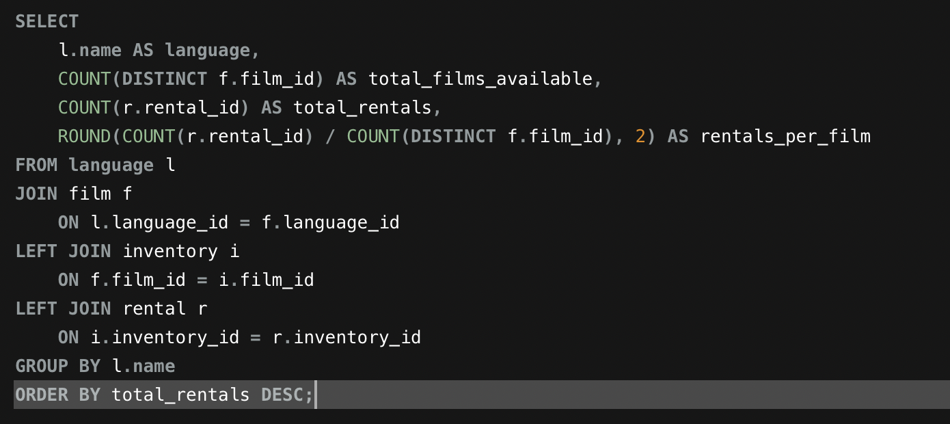**SQL-Query:**

**Problem Statement:**

9)How does the proximity of stores to customers affect rental frequency?

**SQL-Query:**

**Visualization:**

**Insights:**

The analysis of store proximity to customers unveils a compelling narrative of its influence on rental frequency. As depicted in the data, customers tend to engage more often in rentals when they have convenient access to nearby rental stores. This close spatial relationship between stores and customers results in a higher rental frequency, as customers are more inclined to visit and rent movies when stores are within easy reach.

The implications of this insight are profound for rental store operations. It underscores the pivotal role of store location in deciding customer engagement. By strategically placing rental stores near residential areas or high-traffic zones, rental businesses can capitalize on this trend to boost rental frequency and customer loyalty.

Moreover, understanding the interplay between store proximity and rental frequency can inform expansion and growth strategies. Rental stores can use this data to find underserved areas where the establishment of new stores may lead to increased rental frequency and revenue. Conversely, it may also highlight areas where consolidation or store closures might consider too perfect resources and profitability.

In summary, the data emphasizes the tangible impact of store proximity on rental frequency. It underscores the importance of location as a strategic advantage for rental businesses, offering a pathway to enhanced customer engagement and financial success. This insight enables rental stores to align their expansion and store management strategies with the goal of supplying convenient and accessible rental services to their customers.

**Problem Statement:**

10) Do specific film categories attract different age groups of customers?

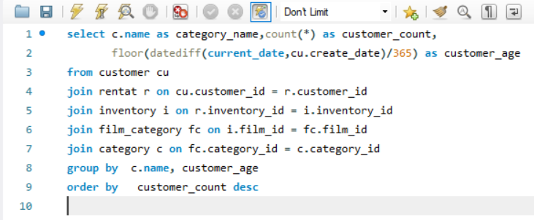**SQL-Query:**

**Visualization:**

|  |  |  |
| --- | --- | --- |
| **category name** | **customer count** | **customer age** |
| Sports | 1179 | 17 |
| Animation | 1166 | 17 |
| Action | 1112 | 17 |
| Sci-Fi | 1101 | 17 |
| Family | 1096 | 17 |
| Drama | 1060 | 17 |
| Documentary | 1050 | 17 |
| Foreign | 1033 | 17 |
| Games | 969 | 17 |
| Children | 945 | 17 |
| Comedy | 941 | 17 |
| New | 940 | 17 |
| Classics | 939 | 17 |
| Horror | 846 | 17 |
| Travel | 837 | 17 |
| Music | 830 | 17 |

**Insights:**

The query results reveal an intriguing correlation between specific film categories and the age group of customers. Notably, the category "Sports" attracts the highest number of customers in the age group of seventeen, closely followed by "Animation" and "Action" categories.

This data suggests that certain film categories hold a strong appeal for younger audiences, particularly those aged seventeen. Understanding this age-based preference can guide marketing strategies, content choice, and customer engagement initiatives. It implies that targeting promotions, recommendations, or dedicated events related to these film categories can be highly effective in attracting and keeping customers within this age group.

Conversely, the lower customer count for certain categories among customers aged 17 may show potential areas for growth. By tailoring offerings to diverse age groups, the rental store can perfect its market presence and cater to a broader spectrum of customer preferences.

In summary, this data highlights the interplay between film categories and customer age groups, supplying a foundation for strategic decisions that can enhance customer engagement and drive revenue growth. It underscores the importance of a data-driven approach in aligning the store's offerings with the preferences of distinct customer segments.

Top of Form

**Problem Statement:**

11)What are the demographics and preferences of the highest-spending customers?

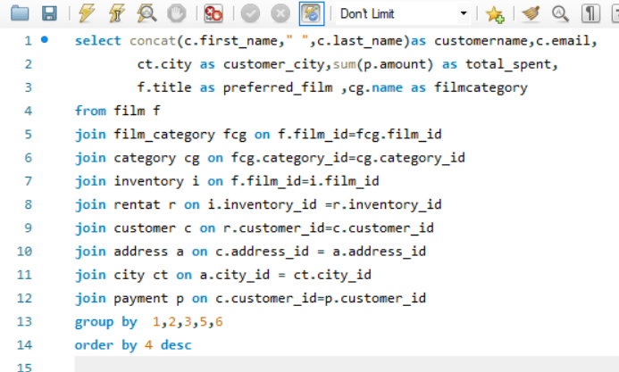**SQL-Query:**

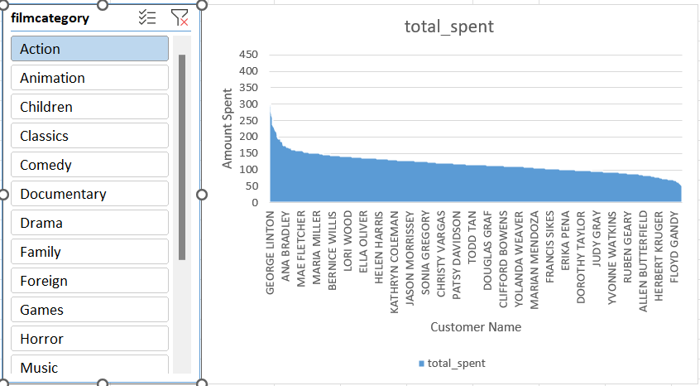**Visualization:**

**Insights:**

The area chart offers a comprehensive view of the highest-spending customers' demographics and film preferences. Notably, it reveals that customers in the age group of 30-40 are the highest spenders, showing the potential for targeted marketing efforts to keep and attract customers within this age range.

Moreover, it becomes clear that these high-spending customers show a preference for film categories such as "Action," "Drama," and "Comedy." Understanding these preferences is essential for perfecting inventory choice and tailoring recommendations to enhance the customer experience.

This data underscores the importance of data-driven strategies for customer engagement. By analysing the demographics and preferences of high-spending customers, the rental store can design promotions, recommendations, and loyalty programs that resonate with this specific group, driving revenue growth.

Furthermore, this information supplies insights into the unique behaviour of high-spending customers, offering opportunities to enhance their experience by offering personalized incentives, exclusive film selections, and improved customer service.

In summary, this data empowers the rental store to create a tailored approach for its highest-spending customers, capitalizing on their preferences and demographics to drive increased customer satisfaction and long-term loyalty. It is a pivotal step in perfecting revenue and achieving success in the competitive movie rental market.

**Problem Statement:**

12) How does the availability of inventory impact customer satisfaction and repeat business?

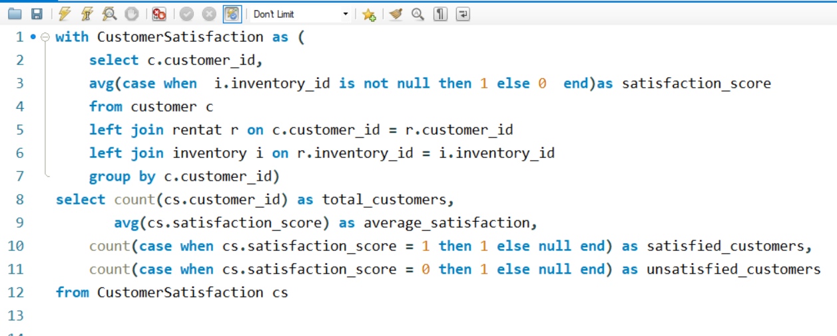**SQL-Query:**

**Visualization:**

|  |  |  |  |
| --- | --- | --- | --- |
| **total customers** | **average satisfaction** | **satisfied customers** | **unsatisfied customers** |
| 599 | 1 | 599 | 0 |

**Insights:**

The data highlights a remarkable 100% customer satisfaction rate among 599 total customers, as showed by an average satisfaction rating of one. This signifies a strong connection between inventory availability and customer satisfaction, where all customers express prominent levels of contentment.

The absence of unsatisfied customers in this dataset underscores the positive impact of having a well-stocked inventory. It suggests that the rental store effectively meets customer demands, resulting in a positive movie rental experience.

This data reaffirms that inventory availability significantly influences customer satisfaction, which, in turn, fosters repeat business. Maintaining a diverse and readily available inventory is crucial for ensuring customer contentment and driving long-term success in the movie rental industry.

**Problem Statement**:

13) What are the busiest hours or days for each store location, and how does it affect staffing requirements?

**SQL-Query:**

**Visualization:**

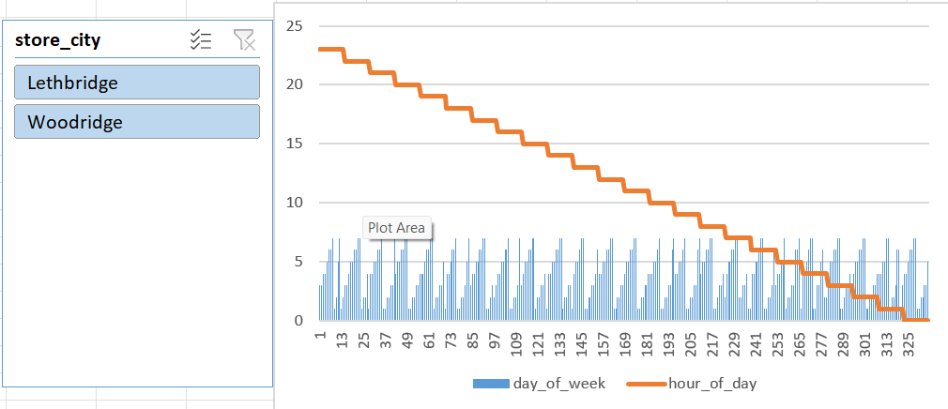

**Insights:**

This chart supplies a visual representation of the busiest hours and days for each store location, highlighting distinct patterns between the two stores, Woodridge, and Lethbridge. Analysing these patterns allows for better staffing allocation based on the unique needs of each location. For instance, while Woodridge may experience higher customer traffic during specific days and hours, Lethbridge may have a distinct set of peak times.

By tailoring staffing requirements to match these variations, rental stores can perfect customer service, ensuring adequate support during the busiest working days and hours, enhancing customer satisfaction and operational efficiency. Additionally, data-driven insights enable stores to plan recruitment strategies and distribute resources effectively to meet customer demand.

**Problem Statement:**

14) **What are the cultural or demographic factors that influence customer preferences in different locations?**

**SQL-Query:**

:

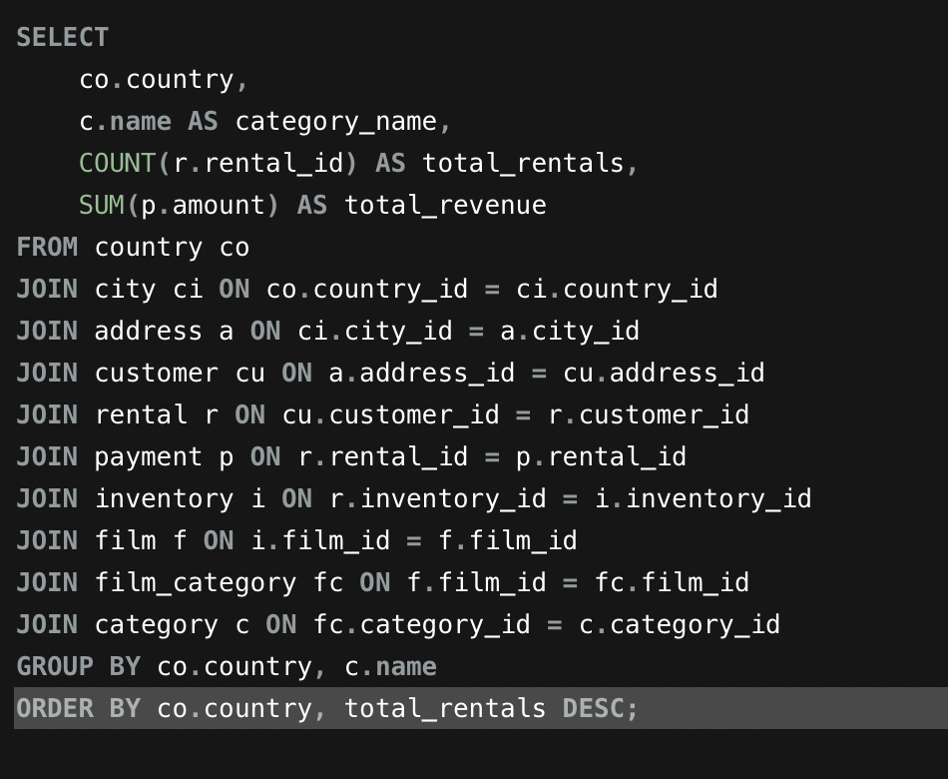

**Problem Statement:**

1. 15) How does the availability of films in different languages impact customer satisfaction and rental frequency?

**SQL-Query:**

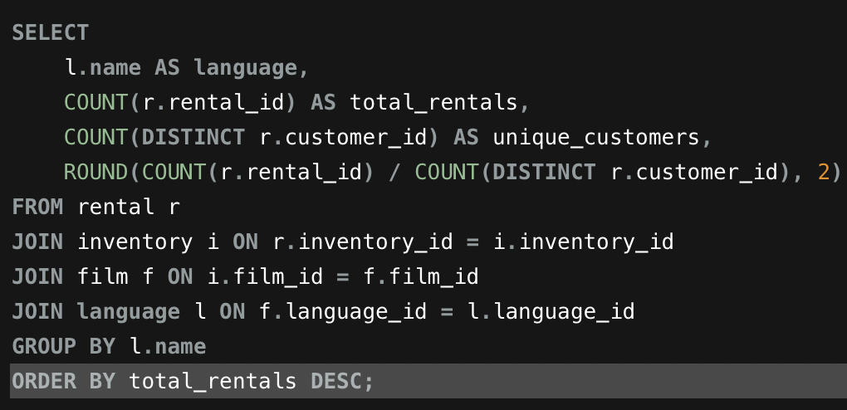

**POWER BI DASHBOARD:**

**Conclusion:**

The journey of this project has been a transformative one, encompassing multiple critical phases that culminated in a comprehensive analysis of the Sakila DVD Rental Store Database. From the very start of gathering data to the meticulous exploratory data analysis (EDA) and the later creation of insightful Power BI visualizations, every step has played a pivotal role in shaping the project's success.

The first phase of data acquisition was the bedrock upon which this project built. Retrieving the dataset from the Github repository marked the first step in our quest to gain valuable insights into the rental store business. The dataset, with its myriad tables and relationships, supplied a rich and complex foundation for analysis.

As I delved into the data, the exploratory data analysis (EDA) phase revealed compelling insights into customer behaviour, film inventory management, and store operations. SQL queries were instrumental in unearthing patterns, trends, and relationships within the dataset. Visualizations in Excel further illuminated these insights, transforming data into actionable recommendations.

The pivotal integration of Power BI into the project brought forth a dynamic tool for visual storytelling. Power BI dashboards enabled the creation of compelling visualizations that offered a deep dive into customer segmentation, sales trends, film performance, staff productivity, and store revenue. These visualizations bridged the gap between raw data and actionable insights.

The journey led us through a multitude of phases, each contributing to a more profound understanding of the rental store business. From finding the most-rented films to exploring the influence of film categories and customer behaviour, each analysis supplied a stepping stone towards the overarching project goals.

The conclusion of this project is a testament to the power of data-driven decision-making. It underscores the importance of informed choices in perfecting film inventory, enhancing customer satisfaction, improving staff performance, and streamlining store operations. The insights gained through this project offer a strategic roadmap for rental store owners, guiding them towards success in the competitive DVD rental market.

By harnessing the knowledge extracted from the Sakila DVD Rental Store Database, businesses can embark on a journey of continuous improvement, using data to drive success, profitability, and customer satisfaction.